One-page abstract for ITC 2025 (title)

***First Author1, Corresponding Author2\****

1Dept. of XXX, University of XXX, Town/City, Country

2 Dept. of XXX, University of XXX, Town/City, Country

*\*E-mail: xxx@xxx.com*

*(1 line spacing)*

The text should be in 11 point Times New Roman with single spacing. We normally recommend the use of 1.0 (single) line spacing. However, when typing complicated mathematical text, it is important to increase the space between text lines to prevent sub- and super-script fonts overlapping one another and making your printed matter illegible.

Figure captions should be centered below the figures; table captions should be centered above. Avoid placing figures and tables before their first mention in the text. Use the abbreviation “Fig. 1,” even at the beginning of a sentence. Figure axis label are often a source of confusion. Use words rather than symbols. Tables should be presented in the form shown in Table1. Their layout should be consistent throughout. Equations are placed in center. If they are numbered, make sure that they are numbered consecutively. Place the numbers in parentheses. Graphics may be full color.

*(1 line spacing)*

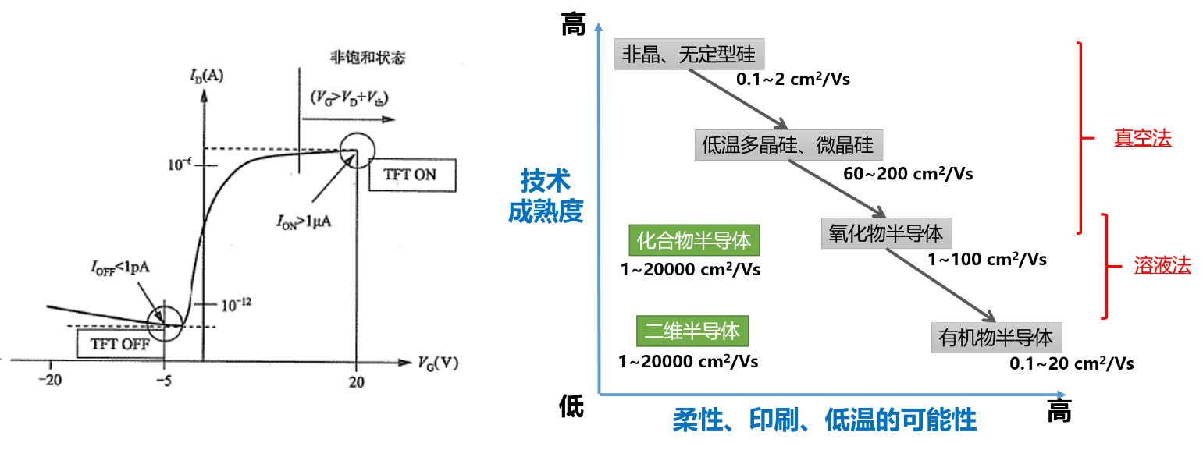

**Fig. 1. Figure captions**

*(1 line spacing)*

This template is for ITC 2025 abstract. Your abstract file (MS word and pdf) should be submitted to secretariat@itc2025.org.

**References**

1. J. Fan, et al., “DC compact model for subthreshold,” *IEEE Elec. Dev. Lett.*,*.* **39** (2018) 1191.

2. C. Auth, et al., "A 22 nm high performance and low-power CMOS technology," in *Proc. Symp. VLSI Tech*., 131, 2012.

3. J. Shannon, Patent no. XXX, (2008).